**Name: Prathamesh Sai Student Number: 19314123**

**QUESTION 1. Connect the circuit below using Multisim placing the voltmeter and ammeters at the locations shown. The supply voltage is:**

**(i) Run the simulation. What do you observe? Please provide a superimposed plot**

**of the voltages and currents using Grapher. [10 Marks]**

**My Circuit:**

**My graph:**

**My observations:**

* The maximum voltage of PR2 is 19.970V, instead of the 20V supply voltage. This could be due to a percentage error in Multisim.
* The minimum voltage of PR2 is -19.970V.

* The maximum current of PR1 and PR3 is 3.1573 A, and the minimum current is -3.1573 A.

* The maximum current of PR4 is 199.70 mA and the minimum current is#

-199.70mA.

**(ii) Calculate the current through the capacitor. Verify your result with the reading**

**from the plot. Why is the supply voltage 90 degrees out of phase with the**

**capacitor current? [20 Marks]**

**This stands to be true with out plot, with a small percentage error. Our plot illustrates 3.1573 Amps but our calculations give us 3.135393438 Amps.**

**Why is it out of phase?**

* When the change in voltage with respect to time, this happens at Vmax. When this is true, we can see from the plot that I = 0 at this point.



* The change of current with respect to time, I(t), is generated by dv(t)/d(t), the change in voltage with respect to time.
* When dv(t)/dt = 0
* v(t) = Vmax
* i(t) = 0
* This is a 90° difference between v(t) and i(t). This explains why the supply voltage is 90° out of phase with the capacitor current.

To prove this mathematically,

I(t) = C

Multiply both sides by Sin

**LHS = Sin I(t) RHS = Sin[ C dv(t)/d(t) ]**

Now if we differentiate with respect to I(t),

LHS = Still contains Sin. RHS= Sin changes to Cos through differentiation.

**Sin and Cos are 90° out of phase with each other. This further proves our point.**

**(iii) Calculate the total current drawn from the source. Compare with the result given**

**by the simulator. [10 Marks]**

The total current drawn from the source = current from capacitor + current from resistor

I (total) = A + current from resistor

Current from resistor = V/R = =

I(total) = +

We can use from Multisim.

**QUESTION 2. Connect up online the circuit below using Multisim:**

**Place voltmeters and an ammeter at the locations indicated. The supply current is:**

**i(t) = 5 Sin (1000 t + /3) A**

**Run the simulation.**

**(i) Calculate the voltage across the inductor. Verify your result by observing this**

**voltage on Grapher. Why is the inductor voltage out of phase by approximately**

**90 degrees with the load (or supply) voltage?**

**[25 Marks]**

**My circuit:**

V = ((5000

**V = 32.65869205 V**

**Observations:**

* Through our calculations, we get 32.65869205 V, but Multisim gives us two values for Voltage when t = 6.5261.

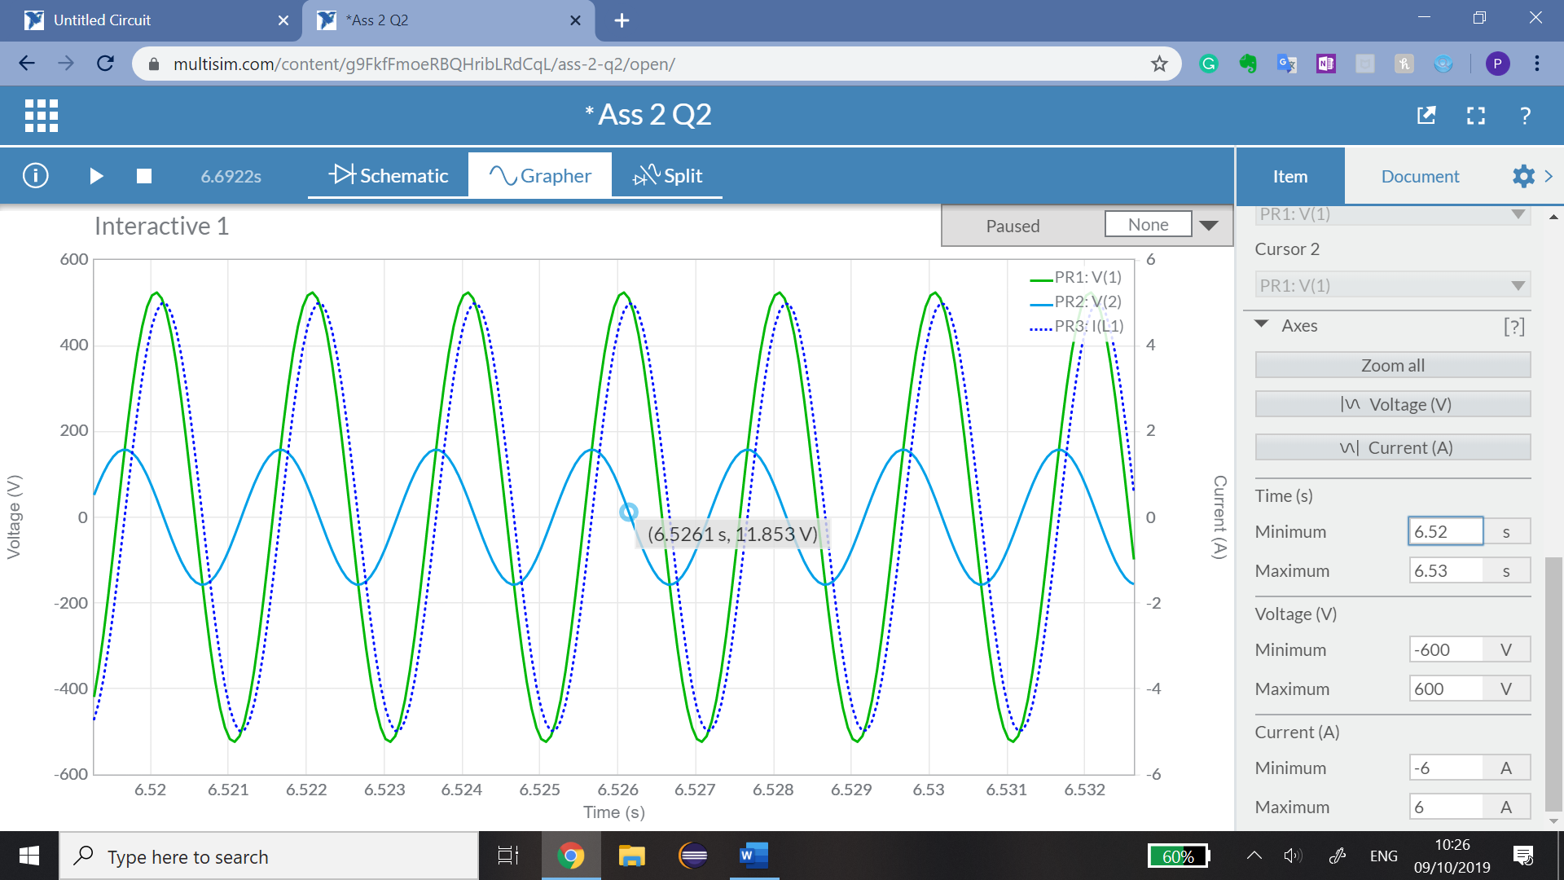

**V = 11.853 V V = 42.478 V**

* Hence, the voltage range **(Vrange) = [11.853 –> 42.475]** when **t = 6.5261**.
* Since our value of **32.65869205 V** is between the range given by Multisim, we can conclude that our calculations were correct.

**Why is it out of phase?**

* When the rate of change of **PR1 (= dv(t)/dt)** is equal to zero, this happens at **Vmax.** At this point, **PR3 = 0 (i.e I = 0).** This means that **the voltage (V) is 90° out of phase with the current (I).**
* Since **V ∝ I**, the Inductor voltage is **90° out of phase** with the supply voltage.



To prove this mathematically,

Multiply both sides by Sin

**LHS = Sin V RHS = Sin[ L ]**

Now if we differentiate with respect to time to get dv(t)

LHS = Still contains Sin. RHS= Sin changes to Cos through differentiation.

**Sin and Cos are 90° out of phase with each other. Hence the voltage (V) across the inductor is 90° out of phase with the current (I).**

* However, since **V ∝ I**, the voltage across the Inductor is 90° out of phase with the supply voltage.

This further proves our point. This was similar to Question 1 part (ii).

**(ii) Calculate the total voltage across the load (resistor-inductor combination). Verify**

**(approximately) your result by observing this voltage on Grapher.**

**[15 Marks]**

* We already have the voltage across the inductor from part (i), so we only need to calculate the voltage of the resistor.
* To find the voltage across the resistor, we use:

**V = 489.0738004 volts**

This value is approximately equal to the value given by Multisim for the voltage across PR1 (the resistor which is 524.06V.

**Voltage across inductor voltage across resistor total voltage across the load**

**32.65869205 V + 489.0738004 V = 521.7324925 V**

* **This is the value of the total voltage across the load (resistor-inductor combination)**

* We can verify this result approximately with Multisim.
* Multisim calculates **524.06 V**
* Our calculations calculate **521.7324925 V**

**This verifies our calculations for part (ii) and hence proves our point.**